Модели данных и СУБД

Кузьмина Анна Викеньтевна

Контрольная работа №1: Проектирование БД и языке DDL

Жуковский Павел Сергеевич, 3 курс, 12 группа

Вариант 6

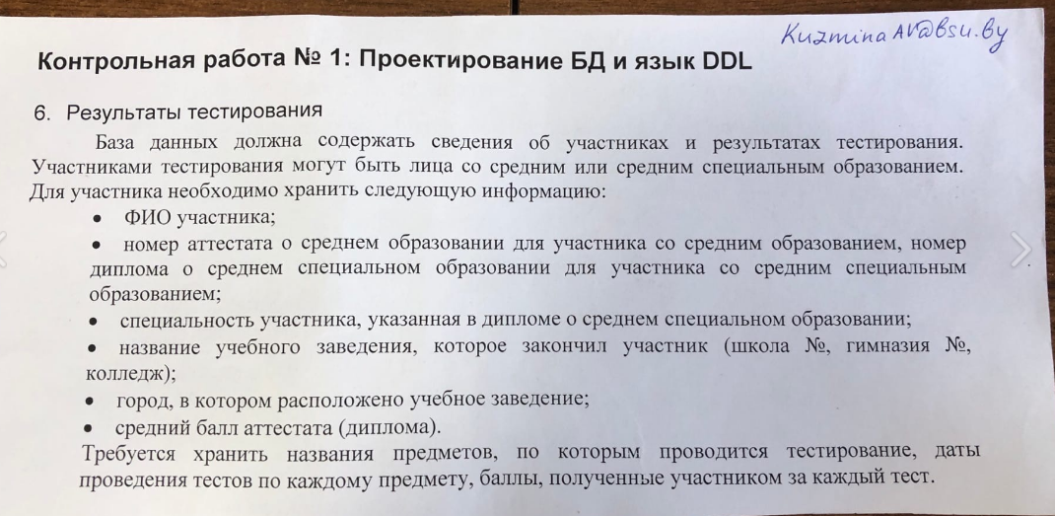

Скриншот логической модели:

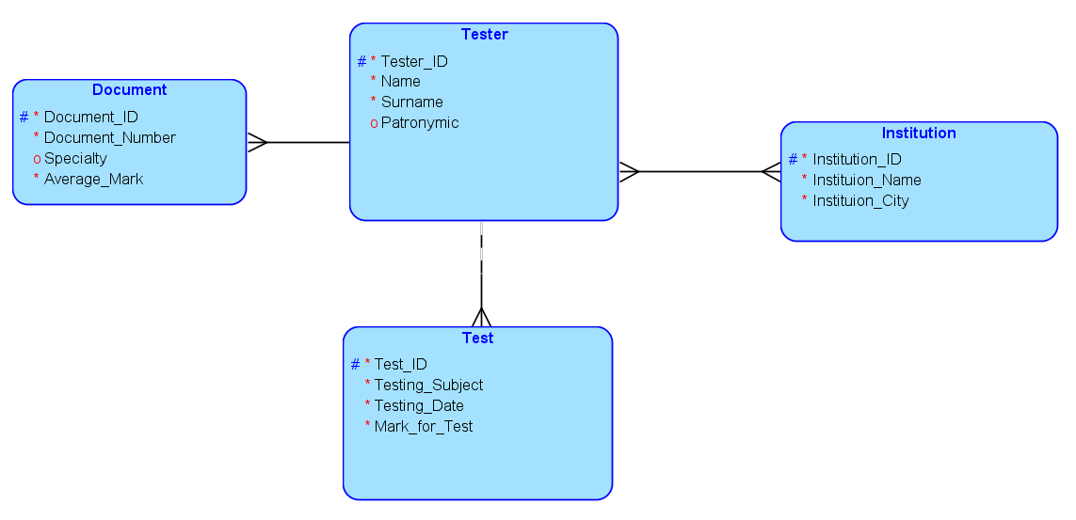

Скриншот физической модели:

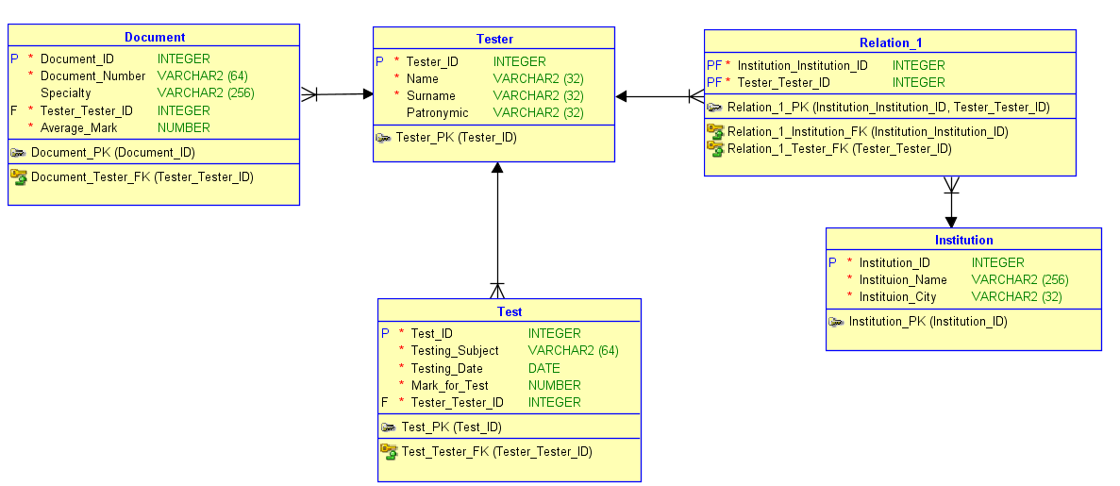

DDL-скрипт:

-- Generated by Oracle SQL Developer Data Modeler 20.2.0.167.1538

-- at: 2020-10-14 15:09:25 MSK

-- site: Oracle Database 11g

-- type: Oracle Database 11g

-- predefined type, no DDL - MDSYS.SDO_GEOMETRY

-- predefined type, no DDL - XMLTYPE

CREATE TABLE document (

document_id INTEGER NOT NULL,

document_number VARCHAR2(64) NOT NULL,

specialty VARCHAR2(256),

tester_tester_id INTEGER NOT NULL,

average_mark NUMBER NOT NULL

);

ALTER TABLE document ADD CONSTRAINT document_pk PRIMARY KEY ( document_id );

CREATE TABLE institution (

institution_id INTEGER NOT NULL,

instituion_name VARCHAR2(256) NOT NULL,

instituion_city VARCHAR2(32) NOT NULL

);

ALTER TABLE institution ADD CONSTRAINT institution_pk PRIMARY KEY ( institution_id );

CREATE TABLE relation_1 (

institution_institution_id INTEGER NOT NULL,

tester_tester_id INTEGER NOT NULL

);

ALTER TABLE relation_1 ADD CONSTRAINT relation_1_pk PRIMARY KEY ( institution_institution_id,

tester_tester_id );

CREATE TABLE test (

test_id INTEGER NOT NULL,

testing_subject VARCHAR2(64) NOT NULL,

testing_date DATE NOT NULL,

mark_for_test NUMBER NOT NULL,

tester_tester_id INTEGER NOT NULL

);

ALTER TABLE test ADD CONSTRAINT test_pk PRIMARY KEY ( test_id );

CREATE TABLE tester (

tester_id INTEGER NOT NULL,

name VARCHAR2(32) NOT NULL,

surname VARCHAR2(32) NOT NULL,

patronymic VARCHAR2(32)

);

ALTER TABLE tester ADD CONSTRAINT tester_pk PRIMARY KEY ( tester_id );

ALTER TABLE document

ADD CONSTRAINT document_tester_fk FOREIGN KEY ( tester_tester_id )

REFERENCES tester ( tester_id );

ALTER TABLE relation_1

ADD CONSTRAINT relation_1_institution_fk FOREIGN KEY ( institution_institution_id )

REFERENCES institution ( institution_id );

ALTER TABLE relation_1

ADD CONSTRAINT relation_1_tester_fk FOREIGN KEY ( tester_tester_id )

REFERENCES tester ( tester_id );

ALTER TABLE test

ADD CONSTRAINT test_tester_fk FOREIGN KEY ( tester_tester_id )

REFERENCES tester ( tester_id );

-- Oracle SQL Developer Data Modeler Summary Report:

--

-- CREATE TABLE 5

-- CREATE INDEX 0

-- ALTER TABLE 9

-- CREATE VIEW 0

-- ALTER VIEW 0

-- CREATE PACKAGE 0

-- CREATE PACKAGE BODY 0

-- CREATE PROCEDURE 0

-- CREATE FUNCTION 0

-- CREATE TRIGGER 0

-- ALTER TRIGGER 0

-- CREATE COLLECTION TYPE 0

-- CREATE STRUCTURED TYPE 0

-- CREATE STRUCTURED TYPE BODY 0

-- CREATE CLUSTER 0

-- CREATE CONTEXT 0

-- CREATE DATABASE 0

-- CREATE DIMENSION 0

-- CREATE DIRECTORY 0

-- CREATE DISK GROUP 0

-- CREATE ROLE 0

-- CREATE ROLLBACK SEGMENT 0

-- CREATE SEQUENCE 0

-- CREATE MATERIALIZED VIEW 0

-- CREATE MATERIALIZED VIEW LOG 0

-- CREATE SYNONYM 0

-- CREATE TABLESPACE 0

-- CREATE USER 0

--

-- DROP TABLESPACE 0

-- DROP DATABASE 0

--

-- REDACTION POLICY 0

--

-- ORDS DROP SCHEMA 0

-- ORDS ENABLE SCHEMA 0

-- ORDS ENABLE OBJECT 0

--

-- ERRORS 0

-- WARNINGS 0